Transmitter
AD620ANZ
Sense +
Sense -
Output
47Ω
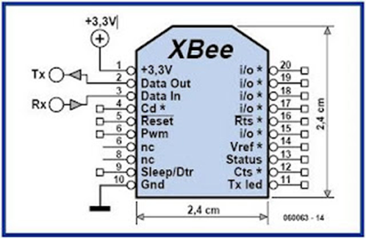

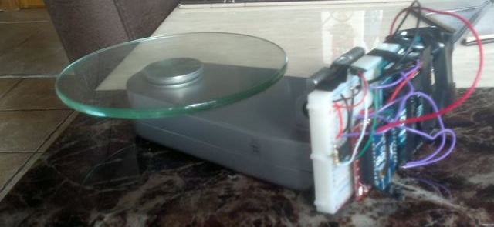
Hacked Weighing Scale
When a mass was placed on the weighing scale this would change the differential voltage between the Sense + and Sense - wires ( from the Wheatstone Bridge configuration featuring the strain gauge) which were fed into the signal amplifier. The 47Ω resistor is used to control the gain of the amplifier ( $G=1+ \frac{49.4 kΩ}{R_{G}}$ ) and for our design the gain was around a thousand times.
The amplifier boosts the differential voltage and the output of the amplifier gets fed into the arduino analogue pin 5. The analogue signal is then quantised and converted to a binary signal by the inbuilt Analogue to Digital Converter in the arduino because the Xbee can only transmit digital signals. The mass information then gets passed to the Din pin of the Xbee via the Tx pin on the arduino where it will be transmitted wirelessly to the receiver Xbee.
Receiver
The Xbee receives the data from the transmittor and then transfers this data to the Rx pin on the arduino via it's Dout pin. The code programmed on the UNO then extracts the mass information from the input Xbee String and based on the mass the Arduino will turn the green LED on and off.
Calibration
The offset error when there was no mass on the scale was recorded and this was then subtracted from all subsequent values in the Arduino code. The resulting value was then divided by the slope of the calibration curve to determine the mass on the scale.

Useful Links
Op Amp Input Offset Voltage:
http://www.analog.com/media/en/training-seminars/tutorials/MT-037.pdf

Digital and Analogue Sampling Using XBees:

http://www.digi.com/support/kbase/kbaseresultdetl?id=3522

Digital Scale Strain Gauge Weight Sensor:
http://www.nerdkits.com/videos/weighscale/
Xbee Communication:
https://learn.sparkfun.com/tutorials/xbee-shield-hookup-guide
Using Xbees to Control a Motor:
http://www.instructables.com/id/Use-xbees-series-2-to-control-a-motor/step5/Connect-the-Xbee-to-the-arduino/

How to Tell which Leg of the LED is Negative:
https://www.westfloridacomponents.com/blog/led-basics-how-to-tell-which-lead-is-positive-or-negative/
Arduino Website:
http://arduino.cc/
FRITZING TUTORIAL 01 - An Introduction to PCB design:
https://www.youtube.com/watch?v=M4CvUSkP9hw
AD620ANZ Data Sheet
http://docs-europe.electrocomponents.com/webdocs/077f/0900766b8077fed7.pdf

